Guidance through Construction Areas

The Americans with Disabilities Act (ADA) and the Manual on Uniform Traffic Control Devices (MUTCD) both require accessibility to be maintained for pedestrians with disabilities when construction disrupts a pedestrian walkway. The MUTCD now clarifies that for pedestrians who are blind, signage, yellow tape and widely spaced cones are not adequate to convey the needed information.

Part 6.D.01 of the MUTCD is on Pedestrian Considerations in Temporary Traffic Control (http://mutcd.fhwa.dot.gov). It states in a standard that:
“If the TTC zone affects the movement of pedestrians, adequate pedestrian access and walkways shall be provided. If the TTC zone affects an accessible and detectable pedestrian facility, the accessibility and detectability shall be maintained along the alternate pedestrian route.” It allows alternate means of providing access in the following option: “If establishing or maintaining an alternate pedestrian route is not feasible during the project, an alternate means of providing for pedestrians may be used, such as adding free bus service around the project or assigning someone the responsibility to assist pedestrians with disabilities through the project limits.”

Although standards and guidance regarding pedestrian access around construction were added to the MUTCD in 2003 and are required by the ADA wherever a pedestrian sidewalk is interrupted, many construction areas are not adequately blocked in accordance with the regulations. Orientation and Mobility specialists, and pedestrians who are blind or who have low vision, may need to report areas that are not adequately marked and remind traffic engineering departments about the requirements.

The 2009 MUTCD includes specifications for detectable edging and pedestrian channelizing devices (which are essentially the same) and recommends use of audible information devices and accessible pedestrian signals in some situations.

Detectable edging
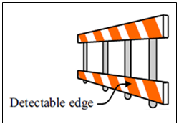
Detectable edging that is continuous, except for gaps where vehicles will be turning or crossing the sidewalk (driveways), is supposed to be at least 6 inches above the surface of the sidewalk, with a bottom edge that is less than 2.5 inches above the surface. There are requirements for the edging to be firmly attached to the ground or to other devices and interconnected.

Channelizing devices

Channelizing devices are used to warn and guide road (and sidewalk) users. The MUTCD requires that devices used to guide or “channelize” pedestrians be detectable to users of long canes and visible to persons having low vision. A continuous detectable bottom and top surfaces that is detectable to users of long canes. The bottom of the bottom surface shall be no higher than 2 inches above the ground and the top of the top surface shall be no lower than 32 inches above the ground.
Figure 1: Example of a Pedestrian Channelizing Device with a Detectable Edge

Audible information devices
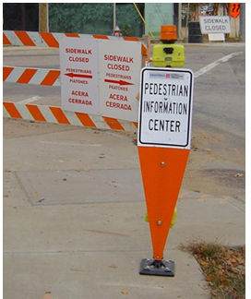
The MUTCD notes that the "most desirable way" to provide guidance through TTCs for people with visual disabilities is "a speech message provided by an audible information device...[which] is needed when the detectable barricade or barrier for an alternate channelized route is not continuous." The best devices are those that provide "speech messages in response to passive pedestrian actuation," although devices that continuously emit a message or emit a message in response to use of a pushbutton are also acceptable. Many devices have motion sensors and repeat the message whenever a pedestrian passes the device. The audible information device needs to be set up at a point where the pedestrian needs to make a decision or detour. For example, if a print sign is being installed telling pedestrians “Sidewalk closed, cross here”, an audible information device is needed to convey that information to pedestrians who are blind. A temporary accessible pedestrian signal may also be necessary for that crossing.
Figure 2: Audible Information Device in Advance of a Closed Sidewalk

Suggested language for use on audible information devices is provided at
http://accessforblind.org/pdf/Messages_for_audible_information_devices_7-2011.pdf

More information can be found in a guide published by American Traffic Safety Services Association in conjunction with the Federal Highway Administration at http://www.workzonesafety.org/fhwa_wz_grant/atssa/atssa_ada_guide
and in the MUTCD at http://mutcd.fhwa.dot.gov/kno_2009r1r2.htm

